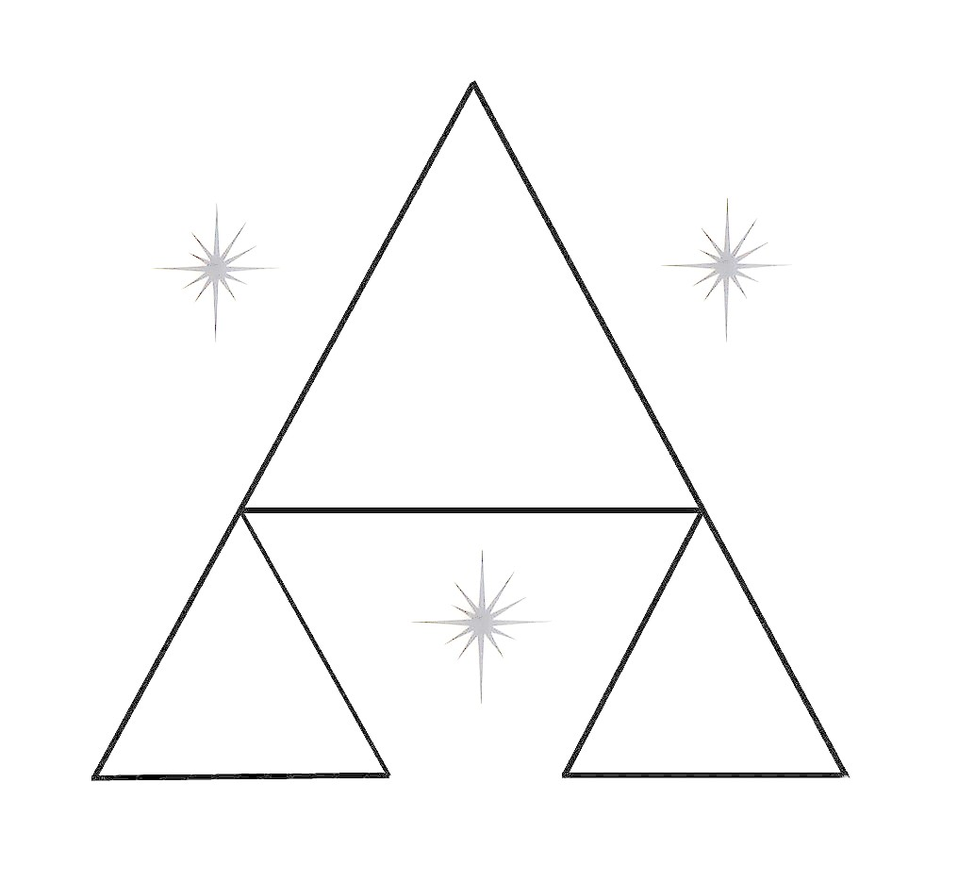
ALAN HOOD PHOTOGRAPHY

Contract for Wedding Photography Services

This agreement is between (Bride) ………………………. and

(Groom)………………………………………………… hereinafter referred to as the "Clients", and [ALAN HOOD PHOTOGRAPHY], hereinafter referred to as the "Photographer(s)".
Date of Wedding: ………………………………………………………………………………
Start Time: [WEDDING START TIME…………………………….........................................
Ceremony
Name of Location: [CEREMONY LOCATION NAME] ……………………………………..
Address: [CEREMONY LOCATION ADDRESS] ………………………………………
Address: [CLIENT 1 ADDRESS………………………………………………………………………………. …….
………………………………………………………………………………………………….
Email: [CLIENT 1 EMAIL……………………………………………………………………
Phone: [CLIENT 1 PHONE] …………………………………………………………………

Address: [CLIENT 2 ADDRESS] ……………………………………………………………..
………………………………………………………………………………………………….
Email: [CLIENT 2 EMAIL]…………………………………………………………………….
Phone: [CLIENT 2 PHONE]………………………………………………………………………………………...
Reception
Name of Location: [RECEPTION LOCATION NAME]
Address: [RECEPTION LOCATION ADDRESS]
Phone: [RECEPTION LOCATION PHONE]
Additional Contact 1
Name: [ADDITIONAL CONTACT 1 NAME]
Mobile Number: [ADDITIONAL CONTACT 1 MOBILE NUMBER]
Additional Contact 2
Name: [ADDITIONAL CONTACT 2 NAME]
Mobile Number: [ADDITIONAL CONTACT 2 MOBILE NUMBER]
Additional contacts must be able to be contacted on the day of the wedding.
Amount agreed: £ [COST OF SERVICES AGREED UPON]
Booking fee/deposit: £ [ Full amount may be paid if total cost is less than £1000.]
The booking fee is due on signing this agreement (Booking Fee is [BOOKING FEE PERCENTAGE] 20% of the amount agreed with a maximum of [BOOKING FEE MAXIMUM]), with the balance of the amount agreed due [BALANCE DUE DATE # 120 DAYS] days before the day of the wedding.
Payment to be made to Barclays Bank: Account Name: Lord Alan Hood.
Sort Code: 20-48-42 Account Number: 23686280.
Cheques are acceptable, and should be made payable to: ALAN HOOD. Mailing Address: Alan Hood Photography, Suite 372, 33 Great George Street,
Leeds LS1 3AJ

Pre-Wedding Consultation: This normally happens at the time of booking. The Clients will outline broadly what is required and the Photographer will advise on planning, logistics and timings where needed. If required the Clients are welcome to meet for an additional chat closer to the time of the wedding (about 2 weeks) to iron out the remaining details. In any case we will contact you a few days before the wedding to ensure that there have been no last-minute changes.
Cooperation: The Clients and the Photographer consent to happily cooperating and communicating with each other to achieve the best possible result within the understanding of this contract. We recommend that the Photographer be provided with a helper (usually the best man) who will point out key individuals to be photographed. The Photographer may also require the assistance of the best man in organizing family groups. The Clients also agree to give the Photographer sufficient warning of key events at the wedding to give the Photographer time to prepare e.g. Bouquet throwing, cutting the cake, speeches etc. Please note that not all guests at weddings like having their photo taken. In such cases the Photographer will use his discretion but cannot be held responsible for a lack of photos of these people.
The Schedule: Our shooting schedule, style of working and experience are designed to achieve a great set of wedding photos for the Clients, accomplished with good humour and enjoyed by all concerned. Both the Clients and the Photographers therefore agree that punctuality and cheerful cooperation are essential to producing outstanding photographic results. In cases where the wedding does not run on time (for example, extreme lateness by one of the Clients arriving to the church) we cannot guarantee to take our normal set of photos although in such circumstances we will do our absolute best to compensate.
Paparazzi Wedding Guests: All your guests will have digital cameras and all your guests will want to photograph the Clients. In the spirit of cheerful cooperation, the Clients agree to give the Photographers precedence over the guests to take the photographs required for the wedding services described above. We cannot be held liable for a lack of wedding photos if guests taking their own photos of the Clients continually interrupt the Photographer's work.
House Rules: Note the Photographers are sometimes limited by rules imposed by registrars, ministers and venue management as to what can and cannot be done. For example, some ministers insist that no flash photography is allowed, and others will insist that the Photographers shoot from a specific location. In such circumstances, the Clients agree to accept the technical limitations that may be imposed on the equipment used. We advise the Clients to make themselves aware of the rules of the venue concerned and if necessary negotiate with the personnel concerned.

